**Find Angle MBC**

https://d3keuzeb2crhkn.cloudfront.net/s3_pub/hr-avatars/d90b1ebf-f0da-466b-a349-6750ed8afcec/150x150.png**by**[**DOSHI**](https://www.hackerrank.com/DOSHI)

* [**Problem**](https://www.hackerrank.com/challenges/find-angle)
* [**Submissions**](https://www.hackerrank.com/challenges/find-angle/submissions)
* [**Leaderboard**](https://www.hackerrank.com/challenges/find-angle/leaderboard)
* [**Discussions**](https://www.hackerrank.com/challenges/find-angle/forum)
* [**Editorial**](https://www.hackerrank.com/challenges/find-angle/editorial)

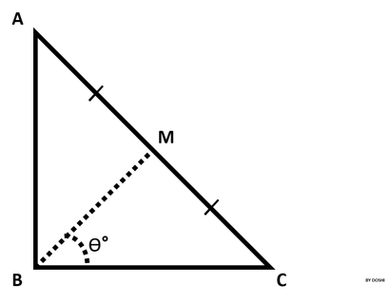 is a right triangle,  at .  
Therefore, .

Point  is the midpoint of hypotenuse .

You are given the lengths  and .   
Your task is to find  (angle , as shown in the figure) in degrees.

**Input Format**

The first line contains the length of side .  
The second line contains the length of side .

**Constraints**

Lengths  and  are natural numbers.

**Output Format**

Output  in degrees.

*Note: Round the angle to the nearest integer.*

**Examples**:  
If angle is 56.5000001°, then output **57°**.  
If angle is 56.5000000°, then output **57°**.  
If angle is 56.4999999°, then output **56°**.

**Sample Input**

10

10

**Sample Output**

45°

**NOTE: Python 3 is disabled for this challenge.**

<https://www.hackerrank.com/challenges/find-angle?h_r=next-challenge&h_v=zen>

import math

AB = int(raw_input())

BC = int(raw_input())

AC = math.sqrt(AB**2 + BC**2)

cos = BC / AC

rad = math.acos(cos) # math.acos(x)=> Return the arc cosine of x, in radians.

print (str(int( round( math.degrees(rad))))+ unichr(176)) #por lo tanto lo paso de radianes a grados con degrees